






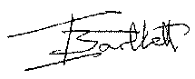
Assistant Chief Constable
Grant Wills
West Mercia Police
Ian Bartlett
Crime Prevention Officer

This is to certify that
Minsterley Primary School
has taken a responsible approach towards ensuring a safer & more secure environment for its pupils, staff and visitors.

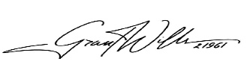
Expires:
26th February 2027

